3dPlant user manual

# Introduction

This manual is a guidance for using *3dPlant* series MATLAB based executables to extract plant structure parameters from 2D images of plant, tiller, leaves, sheaths, culm, panicle and grains (Fig. 1.1), which can later be used in 3D canopy architecture reconstruction.

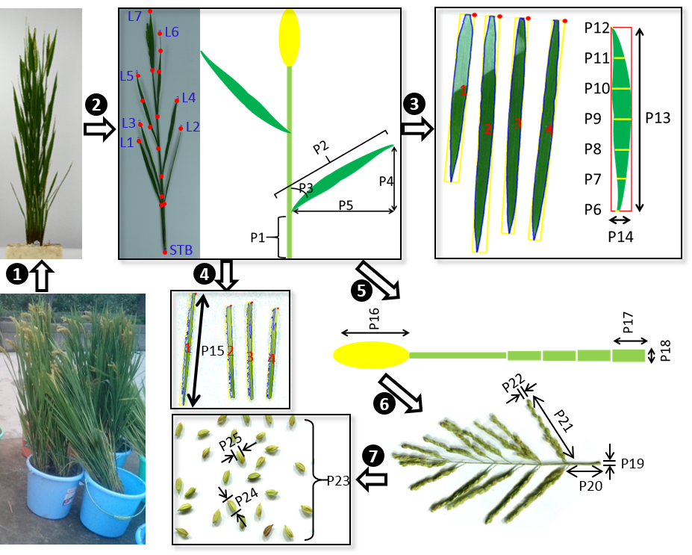

**Figure 1.1 2D photographs taken for 3D plant structure parameter extraction.** Firstly, photos of standing rice plants are taken after they are taken from the field and cleaned. Then, the tillers are detached from plants and photographed. Five parameters are extracted for each leaf on the tiller , i.e. leaf base height (P1), leaf length (P2), leaf base angle (P3), leaf vertical length (P4) and leaf horizontal length (P5). Thirdly, leaves are detached to extract additional 2D features, i.e. leaf width at seven different positions along leaf length (P6-P12), the maximal leaf width (P14) and leaf length (P13). Fourthly, leaf sheaths are detached and the length of each of them (P15) are extracted. Fifthly, the length of panicle (P16), the length (P17) and diameter (P18) of each internode are quantified. Sixthly, the panicle is scanned using a digital scanner to extract detailed 2D features, i.e. the diameter of rachis (P19), base height (P20), length (P21) and diameter (P22) of each primary branch. Finally, the grains are threshed off from panicle and photographed to quantify grain number (P23), grain length (P24) and grain width (P25).

# Preparation

1. Full installation of MATLAB compiler runtime (MCR_win64_installer.exe);
2. Setting higher mouse sensitivity if necessary for more precise key point selection during running of following MATLAB programs. A quick guide can be found here: <https://www.wikihow.com/Change-Mouse-Sensitivity>

# Usage of individual executables forming *3dPlant*

## Tiller structure parameter extraction (TillerAnalyzer_Run.exe)

This program is aimed at extracting leaf base height, leaf length, leaf base angle, leaf vertical length and leaf horizontal length in the images semi-automatically by interacting with the user (Fig. 2.1).



**Figure 2.1 Tiller structure parameter extraction from detached tillers.** Five parameters are extracted for each leaf on the tiller , i.e. leaf base height (P1), leaf length (P2), leaf base angle (P3), leaf vertical length (P4) and leaf horizontal length (P5).

To run this program, double click the TillerAnalyzer_Run.exe file or type in the following commands into windows DOS command window or PowerShell command window:

> .\TillerAnalyzer_Run.exe fileDir save_fig

in which "fileDir" is the directory of images waiting for analyzing. If not given, the default value is current directory; “save_fig”=1 to save each processed images in “fileDir” folder for future reference, “save_fig”=0 to avoid this saving.

During running the program, you will encounter the following processes:

1. The program will ask whether you want to overwrite the existing result files if they presented in the directory:

Overwrite (w) or append (a) to existing result files: w

2. The program will also ask whether you already knew the scale of the images under analyzing:

Do you already know the scale (y) or not (n)?: y

3. If 'yes', you need to type in the scale number (pixels/cm):

Please input the scale number: 44

If 'no', you will be asked to choose an image for setting the scale:

Press ENTER to choose the image for setting the scale now! And press ENTER to exit the image when 2 terminal points have been setting!

Once you choose the 'scale image' (typically is an image with a ruler in it), the image will be presented on the screen, and at this moment the mouse is displayed as a '+' symbol, which is used to choose the region for zooming in (by left mouse click and drag; for better vision when choosing 2 terminal points; double click to redo the zoom-in); after zooming in properly, press ENTER; then left click the mouse to pick the 2 terminal points (Fig. 2.2).

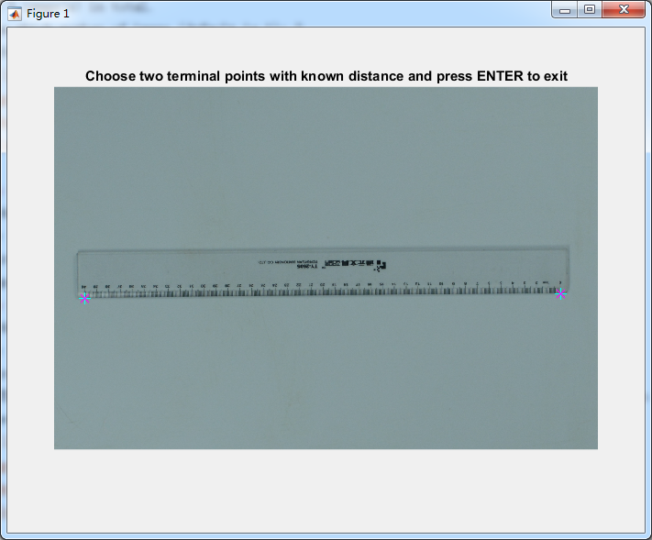

**Figure 2.2 Picking two known distance points after zooming in for afterwards image scale setting.**

After that, press ENTER to exit the image. Then, the program will ask you the true length (cm) between the chosen 2 points:

Please input the scale number: 25

4. After setting the scale, the program will scan the directory and report the total image number in the directory:

There are 5 image(s) in total.

And the program will further ask which number of image you want to start with (in case that some images have already been analyzed):

Start from which number of image (default 1): 2

5. Then the analysis begins:

Img2015-09-21 222021.jpg, the 2/5th image in processing...

6. The image will be presented on the screen and at this moment the mouse is displayed as a '+' symbol, which is used to choose the region for zooming in (by left mouse click and drag; for better vision when picking key points; double click to redo the zoom-in). After zooming in properly, press ENTER.

7. During picking the key-points, you should follow the order presented below:

Step 1. Click the base point of the stem, and some intermediate points on the stem if it is bending, at last click an extension point of the uppermost stem segments (at least should be higher than the base of the uppermost leaf and the base of panicle; Fig. 2.3 left), then press TAB, then a dashed path connecting the points you choose will present and a blue legend written 'ST' will appear besides the first point you click (Fig. 2.3);

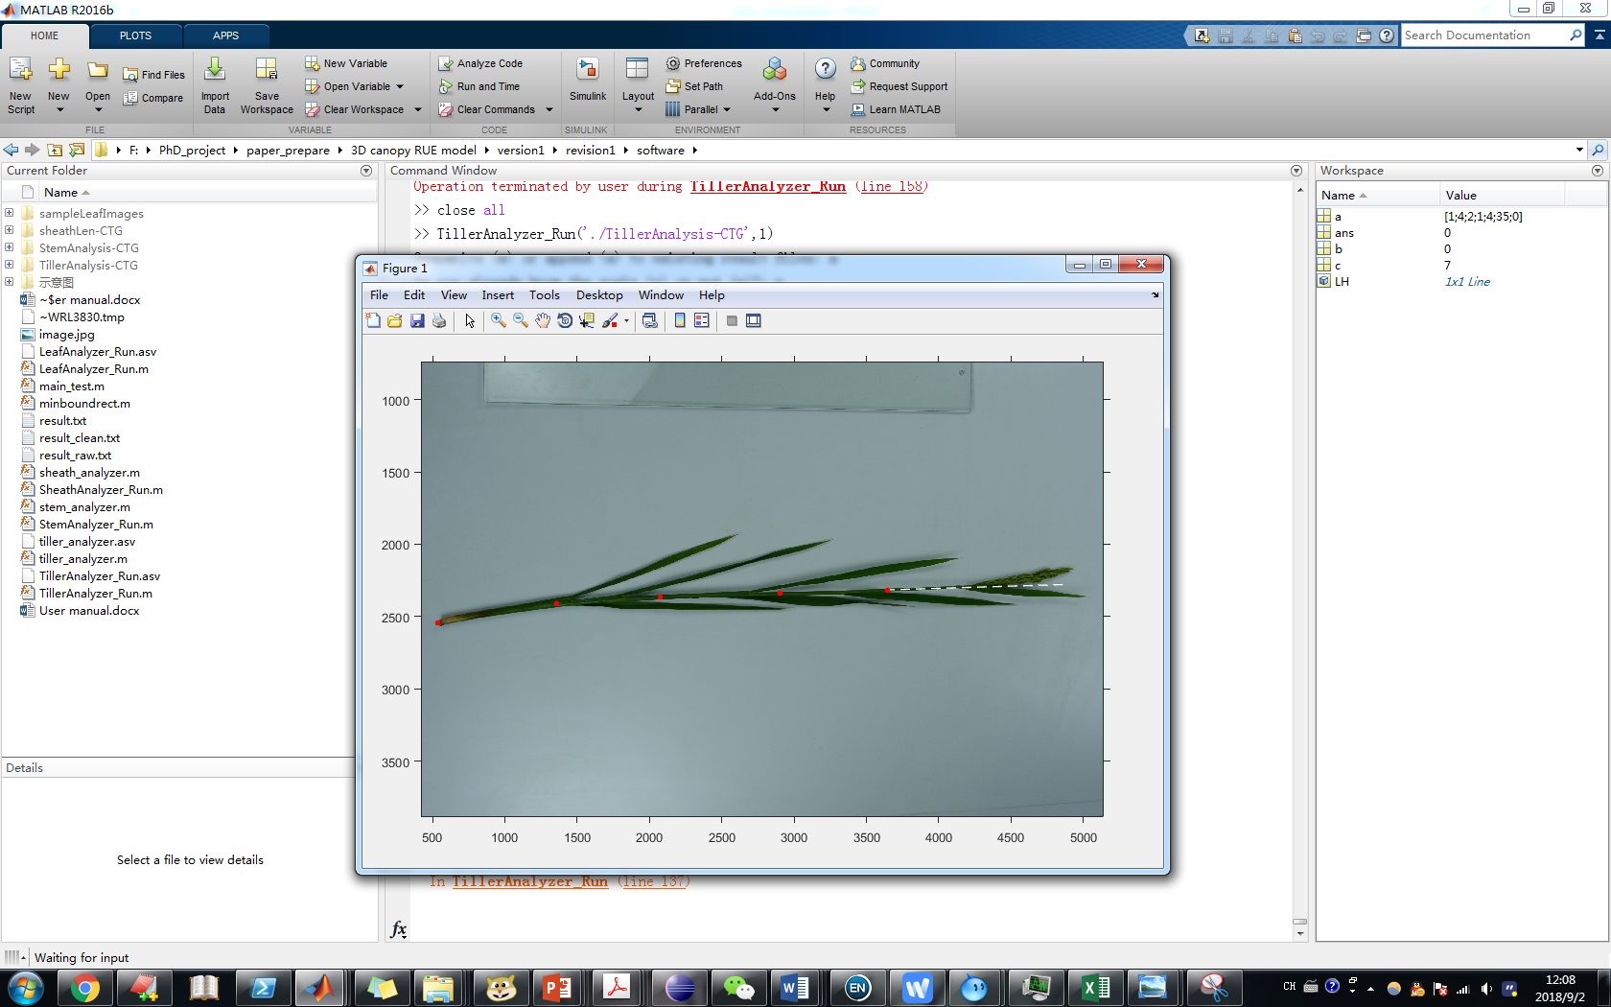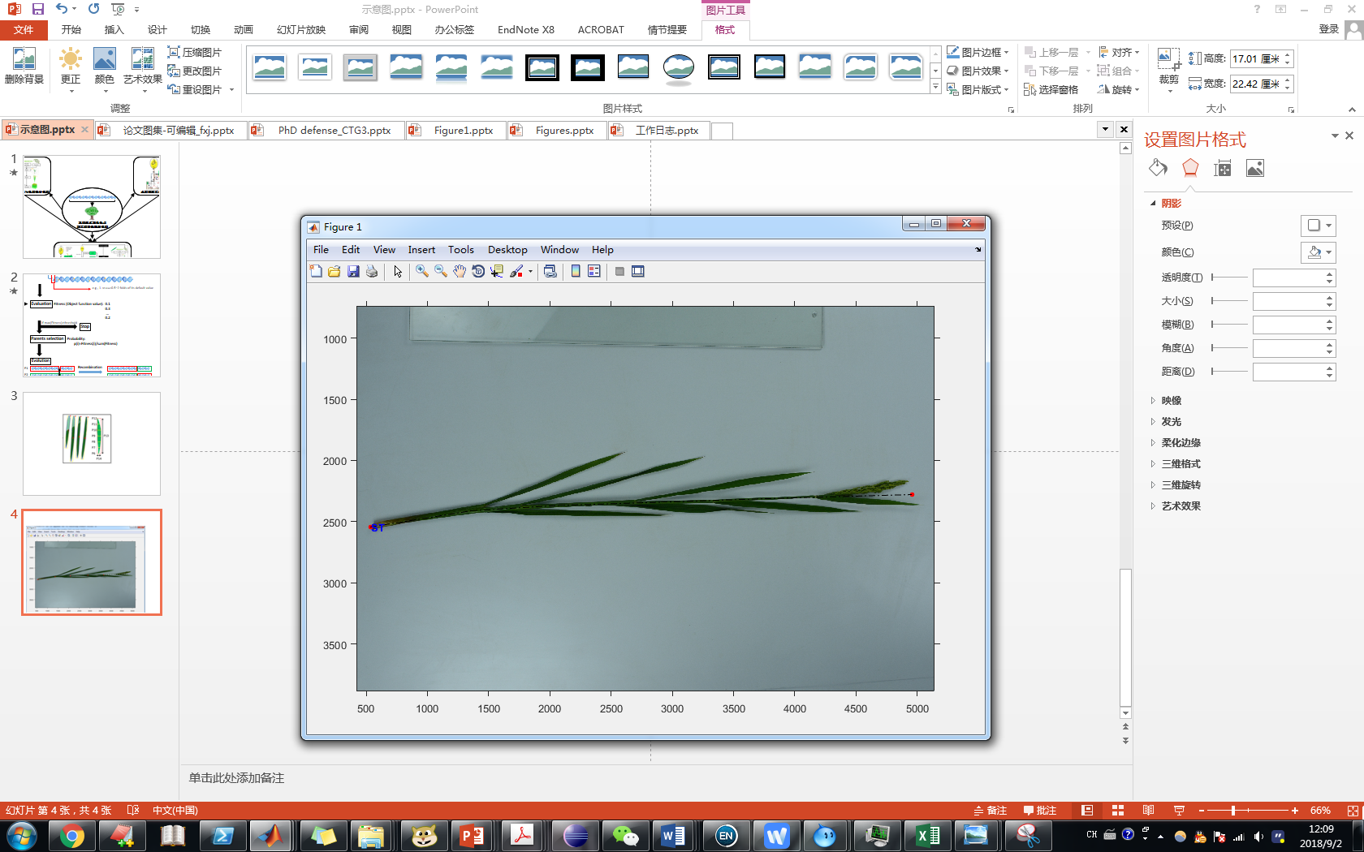

**Figure 2.3. Assigning the path for the stem.**

Step 2. Click the base of the bottom-most leaf, some middle points on the leaf if the leaf is curving, and at last the tip of the leaf, then press TAB (a blue legend written 'L1' will appear besides the leaf-tip point you click; Fig. 2.4);

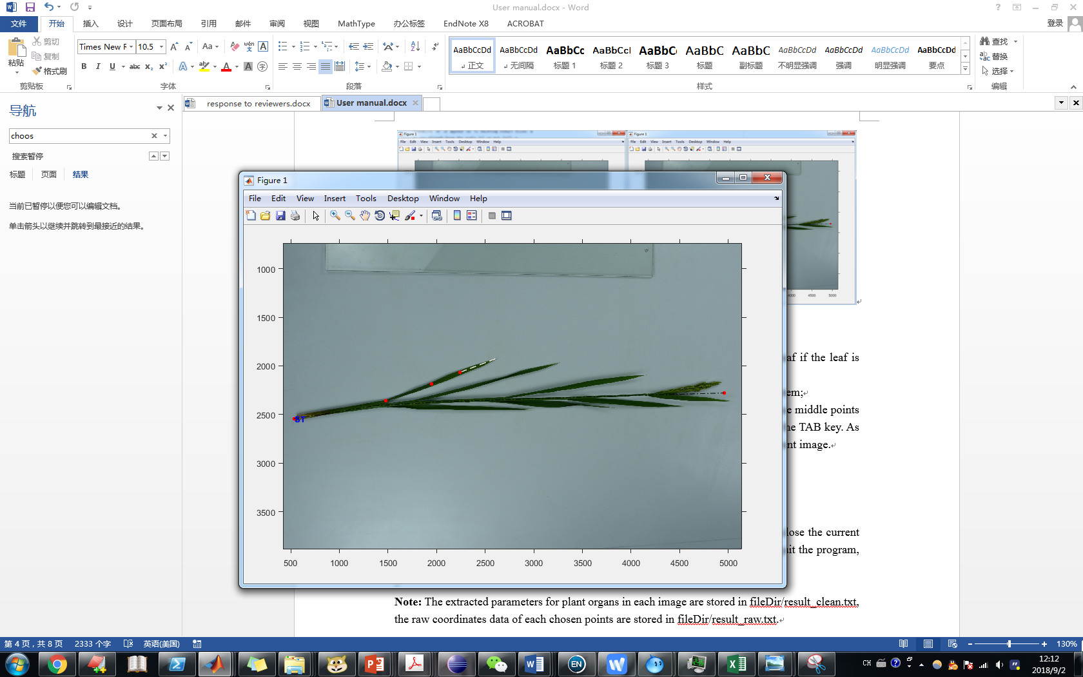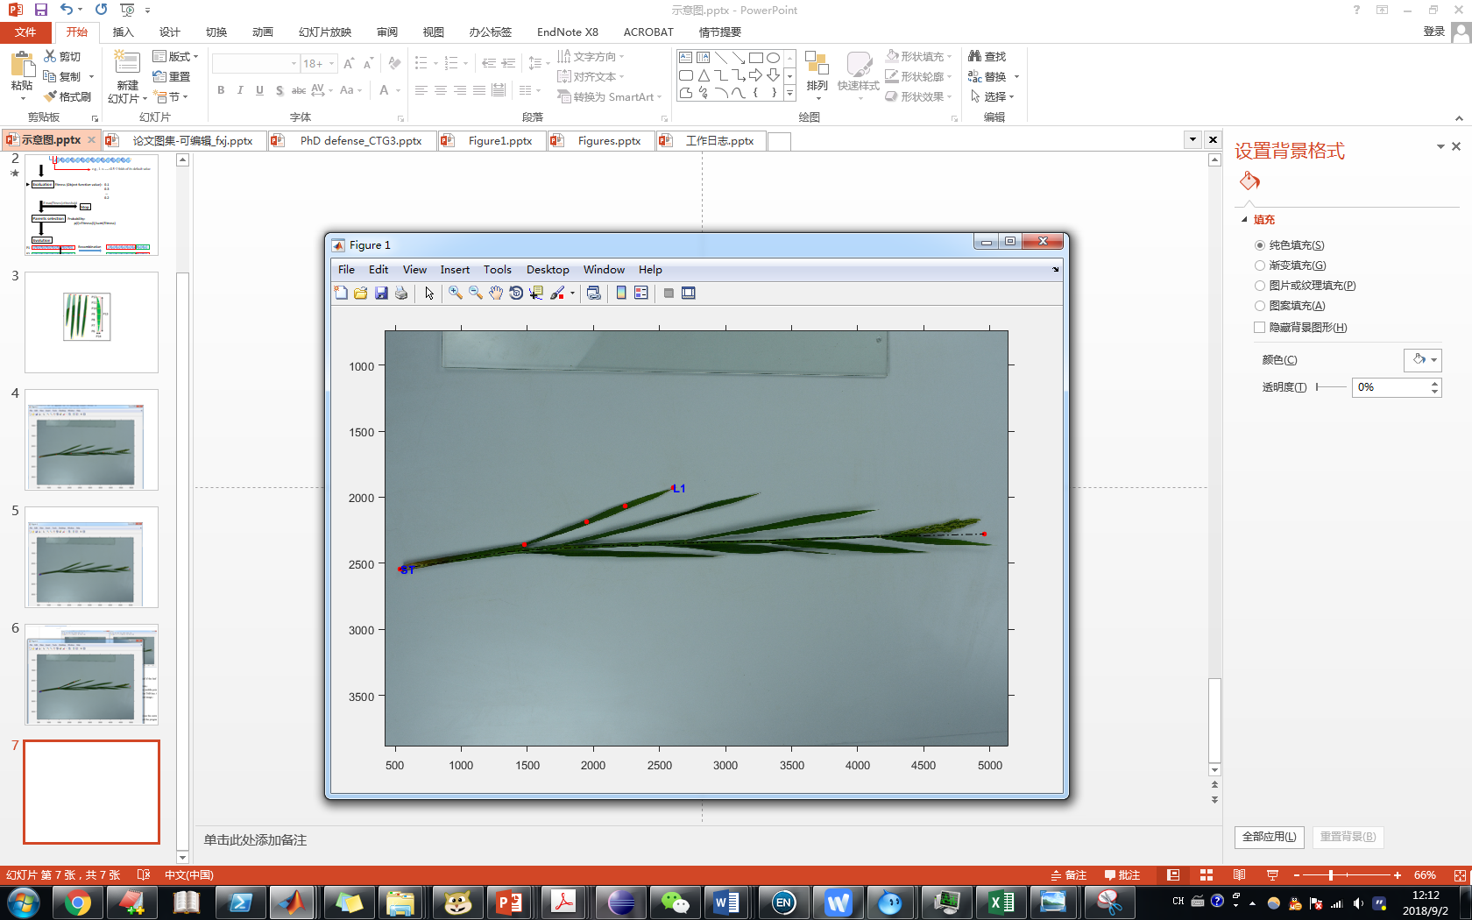

**Figure 2.4. Assigning the path for a leaf.**

Step 3. Repeat Step 2 on other leaves, follow a bottom-up order for leaves on stem;

Step 4. If panicle emerges, click the bottom of the panicle (the white ring), some intermediate points on the panicle if it is curving, and at last the tip of the panicle, then press ‘1’ near the TAB key. As the panicle is the uppermost organ, this operation will finish the processing of current image.

**Remark:** there are some other keyboard events for accidental use

i). 'q', to finish current image processing after all organs have been processed;

ii). 'e', to enter/exit local 'zoom in' mode for help of precise pick of points (Fig. 2.5);

iii). 'z', to undo the wrong pick of points (should only be used after exit of local 'zoom in').

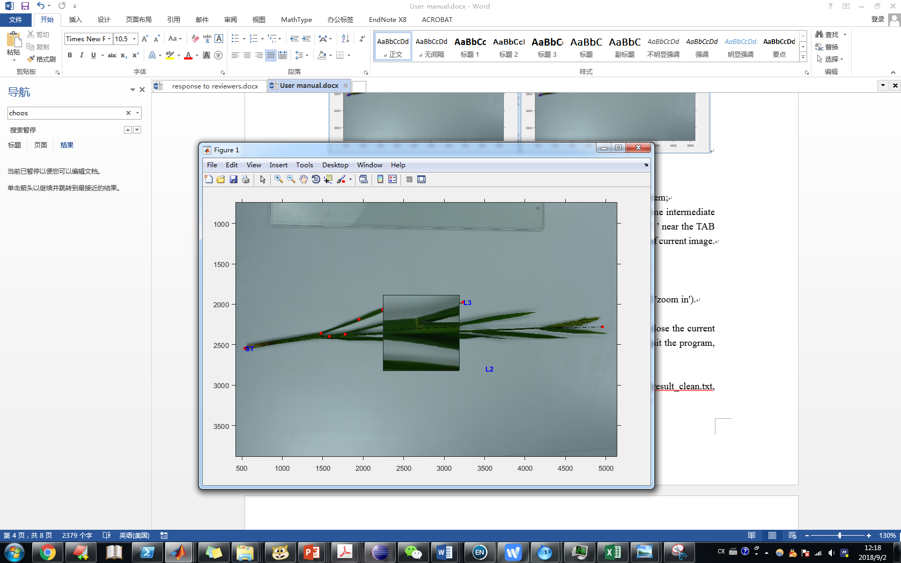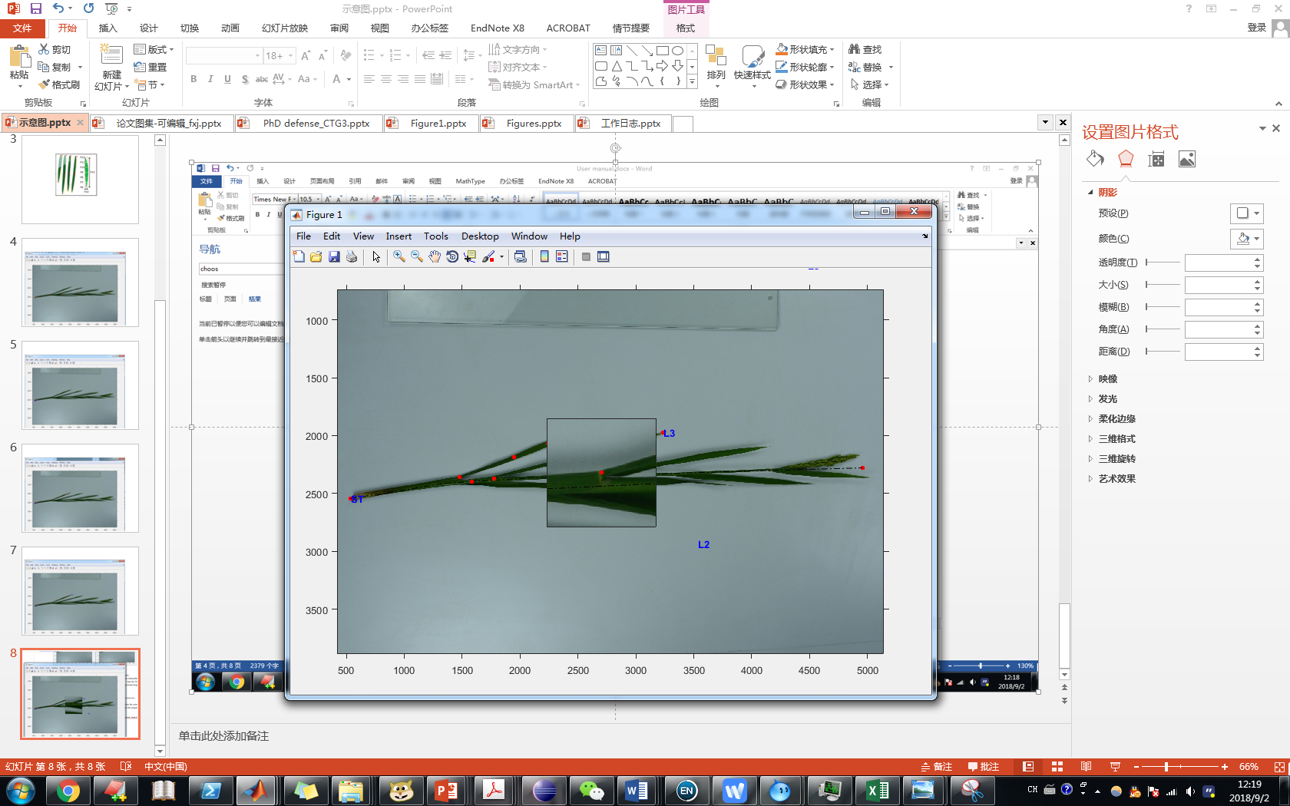

**Figure 2.5. Using 'zoom in' mode to help precise pick of key points.**

8. After finishing processing of one image (press 'q' in step 6), the program will close the current image and ask if you want to start a new image or quit the program. Press 's' to quit the program, press ENTER to start the next image.

Continue to process next figure, press "Enter"; stop here, press "s" and "Enter":

**Note:** The extracted parameters for plant organs in each image are stored in fileDir/result_clean.txt, the raw coordinates data of each chosen points are stored in fileDir/result_raw.txt.

## Leaf shape parameter extraction (LeafAnalyzer_Run.exe)

This program is aimed at extracting length, width, area and width change along length direction of each leaf in the images semi-automatically by interacting with the user (Fig. 3.1).



**Figure 3.1 Leaf shape parameters extraction from detached leaves.** These features are leaf width at seven different positions along leaf length (P6-P12), the maximal leaf width (P14) and leaf length (P13).

To run this program, double click the TillerAnalyzer_Run.exe file or type in the following commands into windows DOS command window or PowerShell command window:

> .\LeafAnalyzer_Run.exe fileDir save_fig arrange_orientation

in which "fileDir" is the directory of images waiting for analyzing, the default value is current directory; default value “save_fig”=1 is to save each processed images in “fileDir” folder for future reference, “save_fig”=0 to avoid this saving; default value “arrange_orientation”=1 stands for a vertical arrangement of leaves in the image (Fig. 3.2 left), “arrange_orientation”=0 stands for a horizontal arrangement of leaves in the image (Fig. 3.2 right).

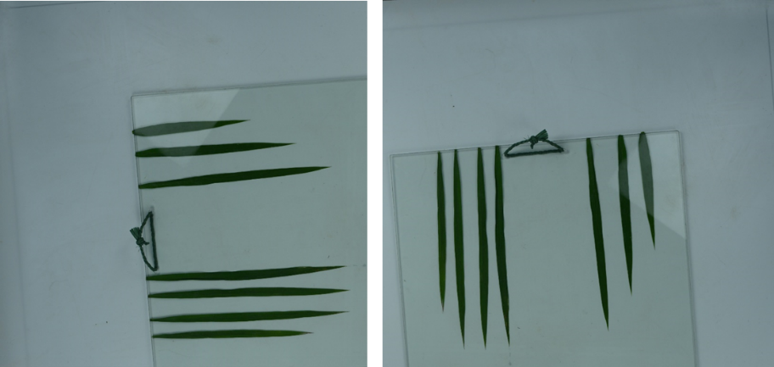

**Figure 3.2 Arrangement of leaves in an image.** Left: vertical arrangement. Right: horizontal arrangement.

During running the program, you will encounter the following processes:

1. The program will ask whether you want to overwrite the existing result files if they presented in the directory:

Overwrite (w) or append (a) to existing result files: w

2. The program will also ask whether you already knew the scale of the images under analyzing:

Do you already know the scale (y) or not (n)?: y

3. If 'yes', you need to type in the scale number (pixels/cm):

Please input the scale number: 44

If 'no', you will be asked to choose an image for setting the scale:

Press ENTER to choose the image for setting the scale now! And press ENTER to exit the image when 2 terminal points have been setting!

Once you choose the 'scale image' (typically is an image with a ruler in it), the image will be presented on the screen, and at this moment the mouse is displayed as a '+' symbol, which is used to choose the region for zooming in (by left mouse click and drag; for better vision when choosing 2 terminal points; double-click to redo the zoom-in); after zooming in properly, press ENTER; then left click the mouse for choosing the 2 terminal points (see Fig. 2.2). After that, press ENTER to continue. Then, the program will ask for the true length (cm) between the chosen 2 points:

Please input the scale (cm): 25

4. After setting the scale, the program will scan the directory and report the total image number in the directory:

There are 5 image(s) in total.

And the program will further ask which number of image you want to start with (in case that some images have already been analyzed):

Start from which number of image (default 1): 2

and some parameters about the raw size of leaves (for filtering dirt from images):

Please set the lower leaf area threshold (cm2, default=0.9):

Please set the lower leaf width threshold (cm, default=0.3):

Please set the lower leaf length threshold (cm, default=3):

Please set the upper leaf area threshold (cm2, default=100):

Please set the upper leaf width threshold (cm, default=3):

Please set the upper leaf length threshold (cm, default=60):

5. Then the analysis begins:

Img2015-09-21 222021.jpg, the 2/5th image in processing...

6. The image will be presented on the screen and at this moment the mouse is displayed as a '+' symbol, which is used to choose the region for zooming in (by left mouse click and drag) if necessary. Press ENTER to move to next step.

**Remark:** there are some other keyboard events for accidental use

iii). 'z', to undo the last improper zooming in.

7. Adjust the brightness of image by dragging the slider if necessary. After that, click outside the slider bar, and press ENTER to move to next step. You can also skip this step by pressing ENTER to move to next step.

8. Click on the image, the mouse will be displayed as a '+' symbol, click to form a polygon barrier to eliminate leaf-like junk object if necessary (Fig. 3.3). Press ENTER to move to next step.

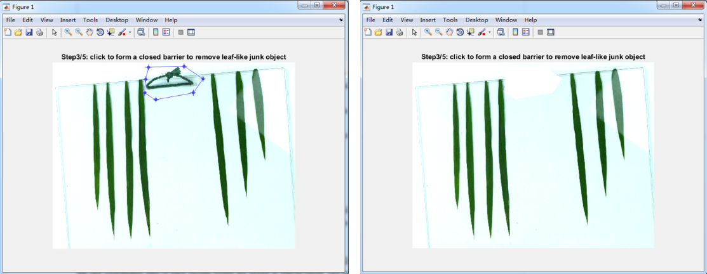

**Figure 3.3 Removing leaf-like junk object from the image.**

8. Adjust the RGB binary threshold for isolating leaves by dragging the first slider (Fig. 3.4a), sometimes this simple method can lead to good enough result. If not, you can also try HSV binary threshold for isolating leaves by dragging the 2-4th slider (Fig. 3.4b). More precise isolation can be done by clicking or click-and-drag regions around leaves to remove the background colors (Fig. 3.4c-d), then drag the slider again to see the result (Fig. 3.4e). The ‘Smooth’ slider is used to make the boundary of leaves more smooth, the ‘erode’ slider is used to erode the image for noise remove. Press ENTER to move to next step.

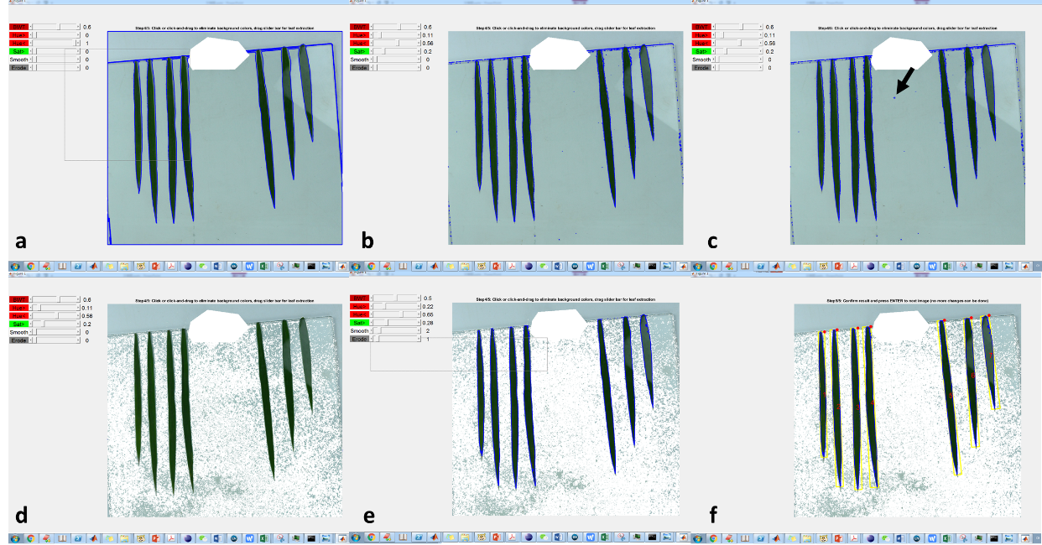

**Figure 3.4 Isolating leaves from the image.** a, drag the first slider to adjust the RGB binary threshold for isolating leaves. b, drag the 2-4th slider to adjust the HSV binary threshold for isolating leaves. c-d, click or click-and-drag mouse to eliminate interference background colors. e, repeat a or b to get a good isolation. f, press ENTER to see the final isolation result.

**Remark:** there are some other keyboard events for accidental use

iii). 'z', to undo the last wrong click or click-and-drag for eliminating interference background colors.

9. The program will show the final isolation result of leaves with yellow minimal bounding rectangle and order of leaves at center of the rectangle (Fig. 3.4f). At this stage no more change can be made. If the result is not correct, you can write down the image name and redo it later. Press ENTER to start the next image.

**Note:** The extracted parameters of leaves in each image are stored in fileDir/result.txt.

## Sheath length extraction (LeafAnalyzer_Run.exe; optional)

LeafAnalyzer_Run.exe can be applied to the extraction of sheath length (Fig. 4.1). Note that sheaths might be damaged during detaching from the stem, so we don’t use the width (diameter) data extracted.

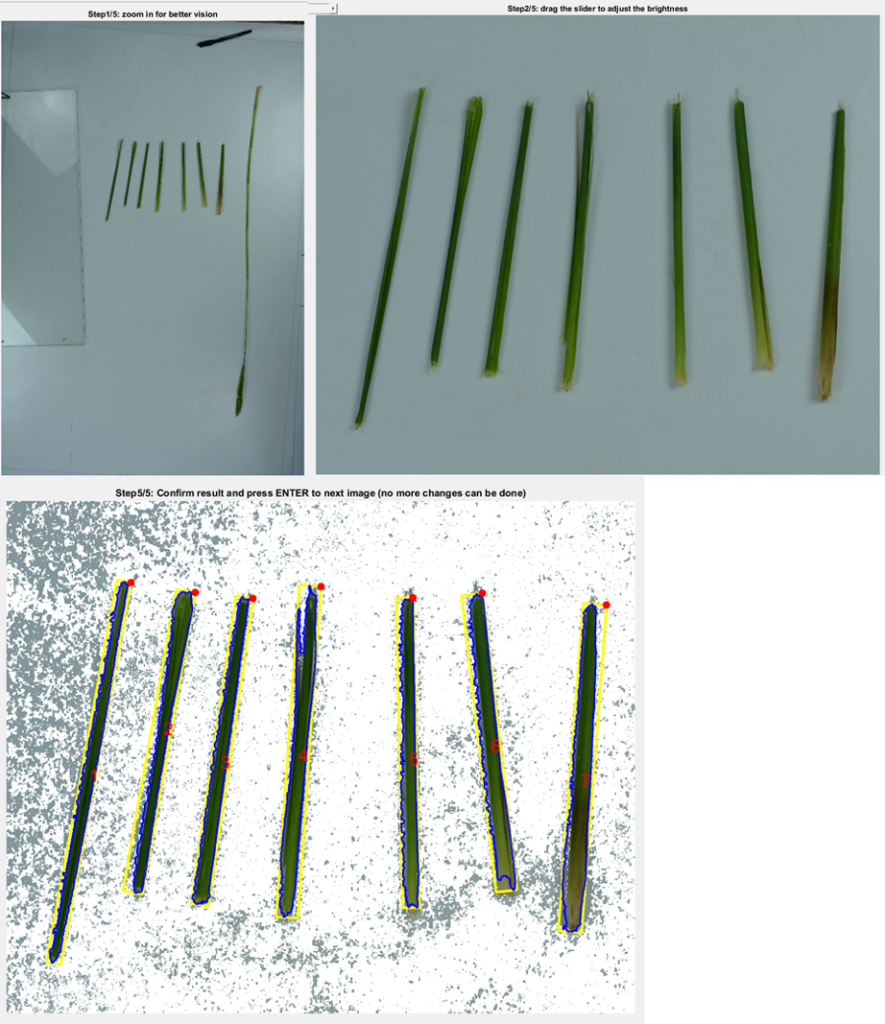

**Figure 4.1 Extraction of sheath length using LeafAnalyzer_Run.exe.**

## Stem structure parameter extraction (StemAnalyzer_Run.exe; optional)

This program is aimed at extracting length and diameter of each internode in the images semi-automatically by interacting with the user (Fig. 5.1).



**Figure 5.1 Extracting stem information in the image.** Specifically, the length of panicle (P16), the length (P17) and diameter (P18) of each internode will be quantified.

To run this program, double click the TillerAnalyzer_Run.exe file or type in the following commands into windows DOS command window or PowerShell command window:

> .\StemAnalyzer_Run fileDir save_fig criteria_d img_complement

in which "fileDir" is the directory of images waiting for analyzing. If not given, the default value is current directory; “save_fig”=1 to save each processed images in “fileDir” folder for future reference, “save_fig”=0 to avoid this saving; “criteria_d” represents the dimension of HSV image used for stem isolation, 1 for using hue, 2 for using saturation, you can try to find the proper one fitting your image; “img_complement” stands for whether to use complement binary image (1) or not (0) to make the stem highlighted, in general, if “criteria_d”=2, it should be set to 0, if “criteria_d”=1 and background is in light color, it should be set to 1.

During running the program, you will encounter the following processes:

1. The program will ask whether you want to overwrite the existing result files if they presented in the directory:

Overwrite (w) or append (a) to existing result files: w

2. The program will also ask whether you already knew the scale of the images under analyzing:

Do you already know the scale (y) or not (n)?: y

3. If 'yes', you need to type in the scale number (pixels/cm):

Please input the scale number: 44

If 'no', you will be asked to choose an image for setting the scale:

Press ENTER to choose the image for setting the scale now! And press ENTER to exit the image when 2 terminal points have been setting!

Once you choose the 'scale image' (typically is an image with a ruler in it), the image will be presented on the screen, and at this moment the mouse is displayed as a '+' symbol, which is used to choose the region for zooming in (by left mouse click and drag; for better vision when choosing 2 terminal points); after zooming in properly, press ENTER; then left click the mouse to pick the 2 terminal points (Fig. 2.2).

After that, press ENTER to exit the image. Then, the program will ask you the true length (cm) between the chosen 2 points:

Please input the scale number: 25

4. After setting the scale, the program will scan the directory and report the total image number in the directory:

There are 5 image(s) in total.

And the program will further ask which number of image you want to start with (in case that some images have already been analyzed):

Start from which number of image (default 1): 2

and some other parameters for helping the information extraction:

Please set the upper limit of stem diameter (cm, default=1.5):

5. Then the analysis begins:

Img2015-09-21 222021.jpg, the 2/5th image in processing...

6. The image will be presented on the screen and at this moment the mouse is displayed as a '+' symbol, which is used to choose the region for zooming in (by left mouse click and drag). After zooming in properly, press ENTER.

7. Adjust the brightness of image by dragging the slider if necessary. After that, click outside the slider bar, and press ENTER to move to next step. You can also skip this step by pressing ENTER to move to next step.

8. During picking the key-points (nodes and panicle tip if there exists), you should follow the bottom-up order, i.e. first click the base of the stem, then the first node, the second node, .... After the pick of the uppermost node, press TAB, then click the tip of panicle, press TAB and then ‘q’ or directly press ‘q’ to finish the selection.

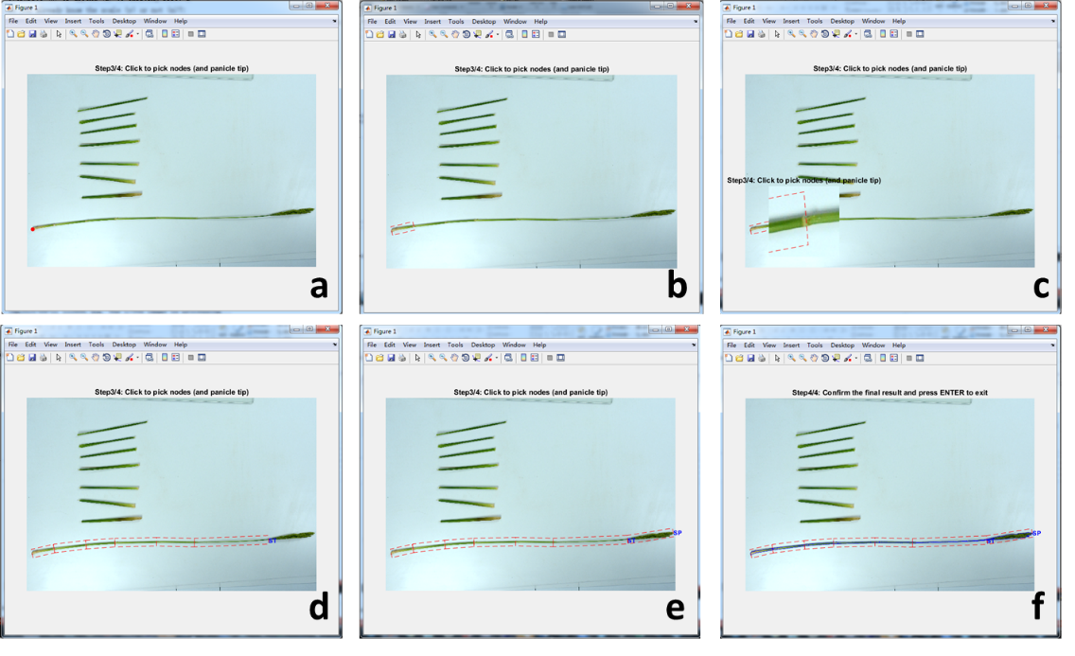

**Figure 5.2 Steps to extract stem information from image.** a, click the base of the stem. b, click the first node. c, click node under zoom-in mode for better precision. d, after all the nodes selection, press TAB (a blue ‘ST’ will appear beside the last node). e, click the tip of panicle, press TAB (a blue ‘SP’ will appear beside the panicle tip). f, press ‘q’ to finish the selection and check the final result.

**Remark:** there are some other keyboard events for accidental use

i). 'q', to finish current image processing after all organs have been processed;

ii). 'e', to enter/exit local 'zoom in' mode for help of precise pick of points (click in the zoom-in panel to select the key point and press ‘e’ again to zoom out; Fig. 2.5);

iii). 'z', to undo the wrong pick of points (should only be used after exit of local 'zoom in').

iv). ‘d’ for setting a break point on the stem (the break should present at the node rather than in the internode) if there exists (Fig. 5.3). Note that for setting a break point between panicle and stem, you need press ‘z’ before press ‘d’, i.e. the button pressing order is TAB -> z -> d.

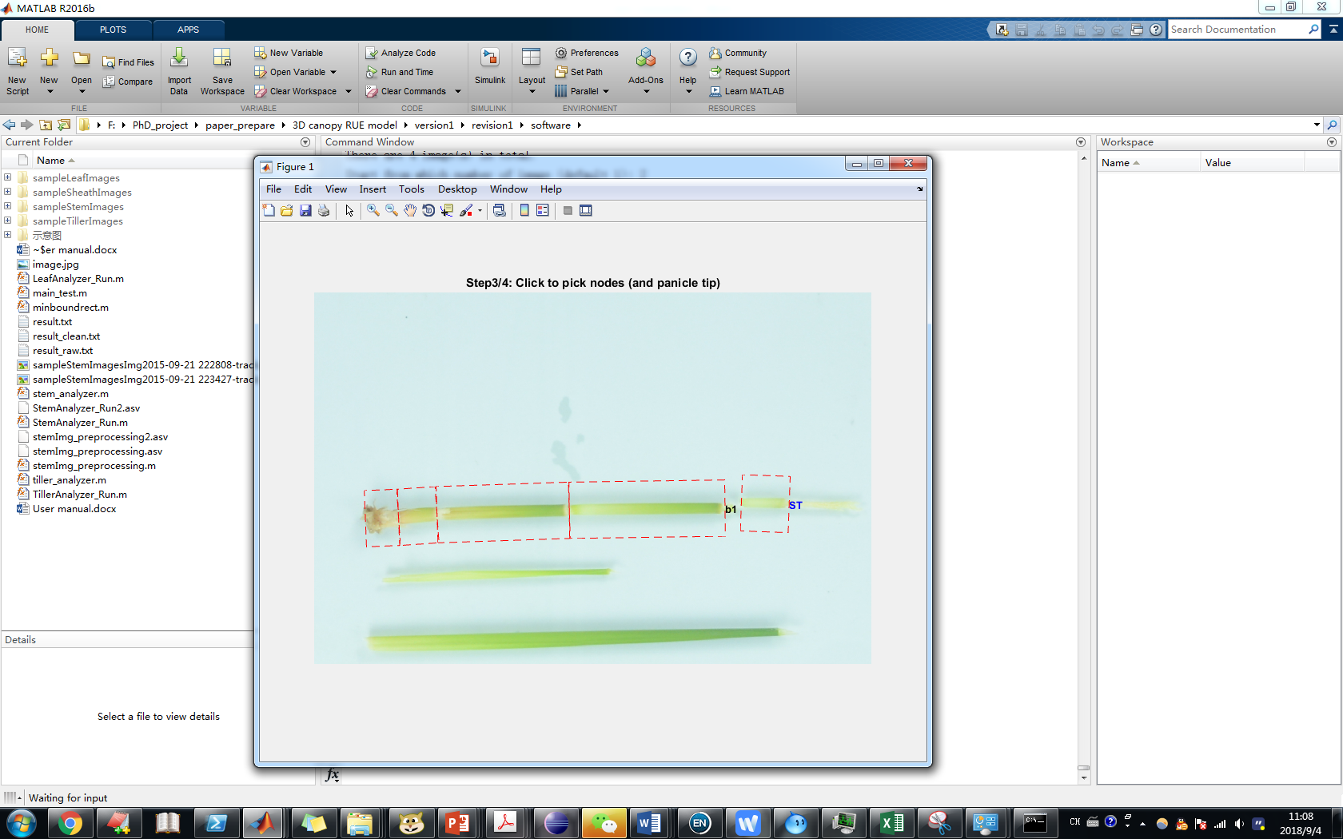

**Figure 5.3 setting a break point on the stem.**

9. After finishing processing of one image (press 'q' in step 8), the program will close the current image and ask if you want to start a new image or quit the program. Press 's' to quit the program, press ENTER to start the next image.

**Note:** The extracted parameters in each image are stored in fileDir/result_clean.txt, the raw coordinates data of each chosen points are stored in fileDir/result_raw.txt.

## Panicle structure parameter extraction (PanicleAnalyzer_Run.exe)

This program is aimed at extracting length and diameter of panicle rachis and primary branches in the images semi-automatically by interacting with the user (Fig. 6.1).

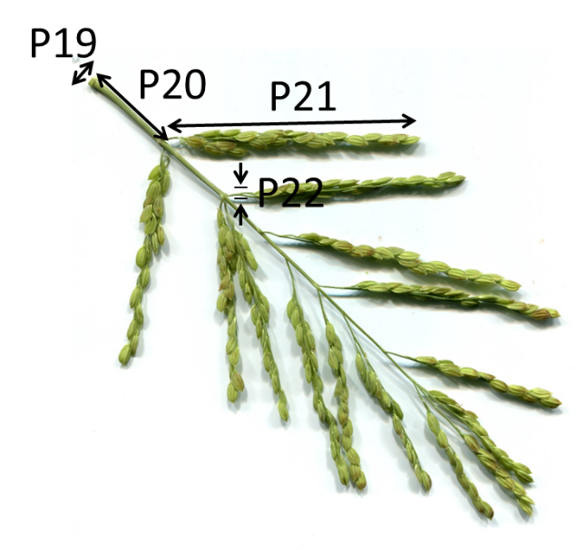

**Figure 6.1 Extracting panicle information in the image.** Specifically, the diameter of rachis (P19), base height (P20), length (P21) and diameter (P22) of each primary branch will be quantified.

To run this program, double click the TillerAnalyzer_Run.exe file or type in the following commands into windows DOS command window or PowerShell command window:

> .\PanicleAnalyzer_Run.exe fileDir save_fig criteria_d img_complement

in which "fileDir" is the directory of images waiting for analyzing. If not given, the default value is current directory; “save_fig”=1 to save each processed images in “fileDir” folder for future reference, “save_fig”=0 to avoid this saving; “criteria_d” represents the dimension of HSV image used for stem isolation, 1 for using hue, 2 for using saturation, you can try to find the proper one fitting your image; “img_complement” stands for whether to use complement binary image (1) or not (0) to make the stem highlighted, in general, if “criteria_d”=2, it should be set to 0, if “criteria_d”=1 and background is in light color, it should be set to 1.

During running the program, you will encounter the following processes:

1. The program will ask whether you want to overwrite the existing result files if they presented in the directory:

Overwrite (w) or append (a) to existing result files: w

2. The program will also ask whether you already knew the scale of the images under analyzing:

Do you already know the scale (y) or not (n)?: y

3. If 'yes', you need to type in the scale number (pixels/cm):

Please input the scale number: 236.28

If 'no', you will be asked to choose an image for setting the scale:

Press ENTER to choose the image for setting the scale now! And press ENTER to exit the image when 2 terminal points have been setting!

Once you choose the 'scale image' (typically is an image with a ruler in it), the image will be presented on the screen, and at this moment the mouse is displayed as a '+' symbol, which is used to choose the region for zooming in (by left mouse click and drag; for better vision when choosing 2 terminal points), press ‘z’ for redoing zoom-in; after zooming in properly, press ENTER; then left click the mouse to pick the 2 terminal points (Fig. 2.2).

After that, press ENTER to exit the image. Then, the program will ask you the true length (cm) between the chosen 2 points:

Please input the scale number: 25

4. After setting the scale, the program will scan the directory and report the total image number in the directory:

There are 5 image(s) in total.

And the program will further ask which number of image you want to start with (in case that some images have already been analyzed):

Start from which number of image (default 1): 2

and some other parameters for helping the information extraction:

Please set the upper limit of stem diameter (cm, default=1.5):

5. Then the analysis begins:

Img2015-09-21 222021.jpg, the 2/5th image in processing...

6. The image will be presented on the screen and at this moment the mouse is displayed as a '+' symbol, which is used to choose the region for zooming in (by left mouse click and drag). After zooming in properly, press ENTER.

7. Adjust the brightness of image by dragging the slider if necessary. After that, click outside the slider bar, and press ENTER to move to next step. You can also skip this step by pressing ENTER to move to next step.

8. Pick the key-points (path of rachis and branches). For the rachis, just click the base (and some intermediate points on the rachis if it is bending) and tip of it (Fig. 6.2a), then press TAB, a dashed line showing the path of rachis and a blue word ‘Rachis’ will appear at the base of rachis (Fig. 6.2b). For picking the branches, you should follow the bottom-up order, for each branches, process it just like what has been done for the rachis, remember to press ‘e’ for a zoom-in view and a more precise selection of key point (Fig. 6.2c), press TAB to finish a branch (a blue word B* will appear at tip of the branch, * is current number of branch; Fig. 6.2d). After the pick of all the branches, press TAB and then ‘q’ or directly press ‘q’ to finish the selection. Then a result image will present, you can visually check if there was some mistake. Press ENTER to finish it.

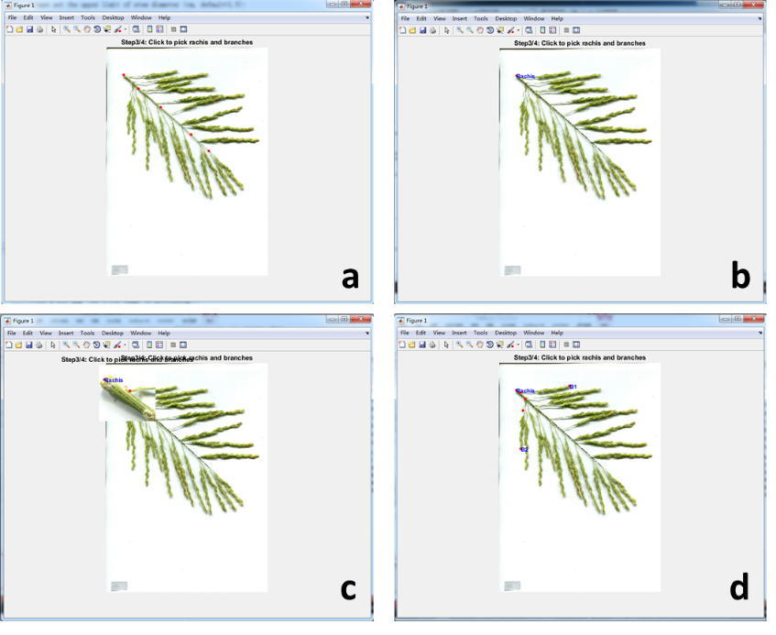

**Figure 6.2 Steps to extract stem information from image.** a, click the base of the stem. b, click the first node. c, click node under zoom-in mode for better precision. d, after all the nodes selection, press TAB (a blue ‘ST’ will appear beside the last node). e, click the tip of panicle, press TAB (a blue ‘SP’ will appear beside the panicle tip). f, press ‘q’ to finish the selection and check the final result.

**Remark:** there are some other keyboard events for accidental use

i). 'q', to finish current image processing after all organs have been processed;

ii). 'e', to enter/exit local 'zoom in' mode for help of precise pick of points (click in the zoom-in panel to select the key point and press ‘e’ again to zoom out; Fig. 2.5);

iii). 'z', to undo the wrong pick of points (should only be used after exit of local 'zoom in').

9. After finishing processing of one image (press 'q' in step 8), the program will close the current image and ask if you want to start a new image or quit the program. Press 's' to quit the program, press ENTER to start the next image.

**Note:** The extracted parameters in each image are stored in fileDir/result_clean.txt, the raw coordinates data of each chosen points are stored in fileDir/result_raw.txt. In fileDir/result_clean.txt, the first column is name of images, the second column is length of rachis and branches, the third column is the minimal diameter of rachis and branches, the 4-10 columns are diameter at 7 different position along each rachis and branches (just like what has been done for leaves, see Fig. 3.1).

## Grain shape parameter extraction (GrainAnalyzer_Run.exe)

This program is aimed at extracting number, length, width, area and area ratio (area/[ length*width]) of grains on a panicle automatically (Fig. 7.1).



**Figure 7.1 Extracting grain information in the image.** Specifically, the grains are threshed off from panicle and photographed to quantify grain number (P23), grain length (P24), grain width (P25) and grain area will be quantified.

To run this program, double click the TillerAnalyzer_Run.exe file or type in the following commands into windows DOS command window or PowerShell command window:

> .\GrainAnalyzer_Run.exe fileDir save_fig

in which "fileDir" is the directory of images waiting for analyzing. If not given, the default value is current directory; “save_fig”=1 to save each processed images in “fileDir” folder for future reference, “save_fig”=0 to avoid this saving.

During running the program, you will encounter the following processes:

1. The program will ask whether you want to overwrite the existing result files if they presented in the directory:

Overwrite (w) or append (a) to existing result files: w

2. The program will also ask whether you already knew the scale of the images under analyzing:

Do you already know the scale (y) or not (n)?: y

3. If 'yes', you need to type in the scale number (pixels/cm):

Please input the scale number: 236.28

If 'no', you will be asked to choose an image for setting the scale:

Press ENTER to choose the image for setting the scale now! And press ENTER to exit the image when 2 terminal points have been setting!

Once you choose the 'scale image' (typically is an image with a ruler in it), the image will be presented on the screen, and at this moment the mouse is displayed as a '+' symbol, which is used to choose the region for zooming in (by left mouse click and drag; for better vision when choosing 2 terminal points); after zooming in properly, press ENTER; then left click the mouse to pick the 2 terminal points (Fig. 2.2).

After that, press ENTER to exit the image. Then, the program will ask you the true length (cm) between the chosen 2 points:

Please input the scale number: 25

4. After setting the scale, the program will request a manual processing of one typical image for setting grain recognition parameters:

Please click ENTER and choose a typical image for setting grain recognition parameters.

5. During the manual processing, firstly the image will be presented on the screen and at this moment the mouse is displayed as a '+' symbol, which is used to crop the image (and images thereafter for automatic processing). Left clicking the mouse and drag, a dashed red rectangle gives the crop boundary, you can reset the choose of region before pressing ENTER (if no need of image crop, directly press ENTER).

6. After that, you should drag the slider bars for an optimal recognition of grains. Specifically,

i). the slider written ‘BWT’ represents the threshold for a simple binarization of the original RGB image, if it doesn’t work well, move to use threshold in the HSV color space, i.e. the ‘Hue>’, ‘Hue<’ and ‘Sat>’ sliders (Fig. 7.2);

ii). the ‘Area>’, ‘Area<’, ‘Len>’, ‘Len<’, ‘Wid>’, ‘Wid<’ sliders represent the lower limit of the grain area (mm2), the upper limit of the grain area (mm2), the lower limit of the grain length (mm), the upper limit of the grain length (mm), the lower limit of the grain width (mm), the upper limit of the grain width (mm). Drag the bars to adapt for a suitable value. Note that some grains may be in aggregation, for which a larger upper limits of area, length and width are needed if you don’t want to lose them (Fig. 7.2).

iii). To make the boundary of grains more smooth, drag the ‘Smooth’ bar; to erode edges for grain segregation, drag the ‘Erode’ bar (Fig. 7.2).

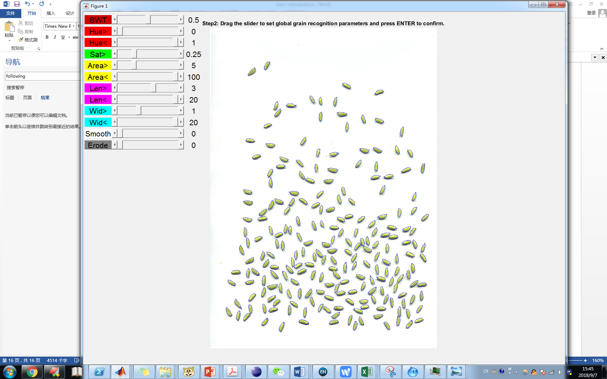

**Figure 7.2 Making an optimal grain recognition by dragging the slider bars on the left.**

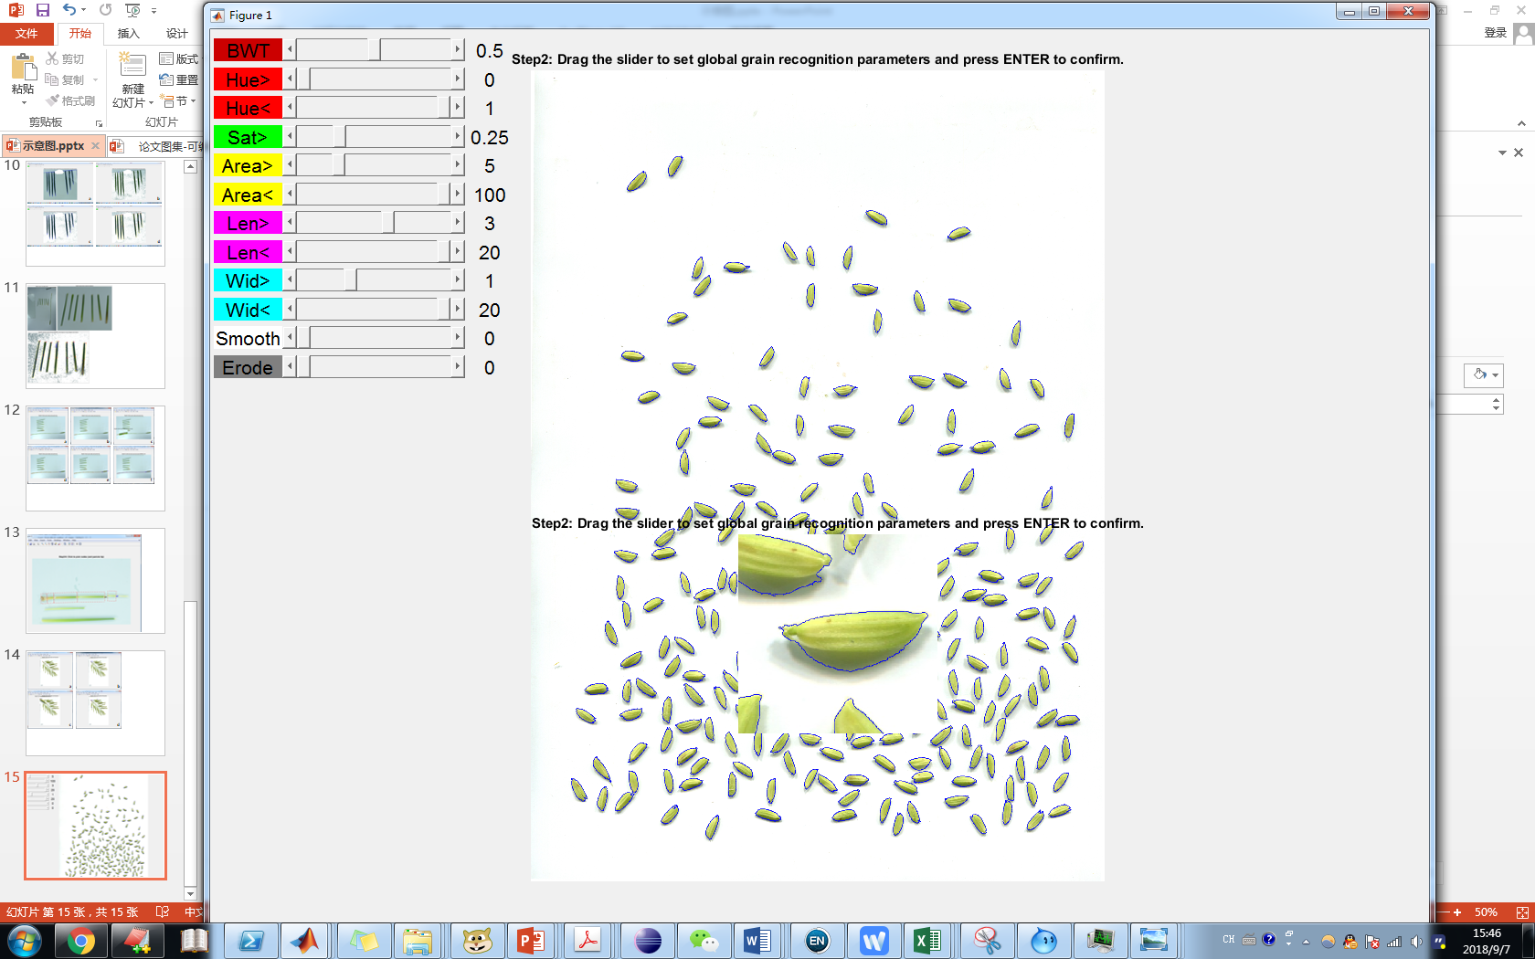

**Figure 7.3 Check the result in detail visually by press ‘e’ after adapting the grain recognition parameters.**

After all the parameters are optimized, press ENTER to continue (the program will use these parameters for all the following images).

7. After all the parameters are optimized, the program will show the value of all parameters and wait for confirmation of an automatic processing of all images in the given folder. Press ENTER to start the processing, press ‘s’ + ENTER to quit the program.

The parameters for grain recognition have been set! They are hue_lower=0.00, hue_upper=1.00, sat_lower=0.30, area_lower=12.0, area_upper=54.7, len_lower=5.0, len_upper=17.6, wid_lower=2.2, wid_upper=9.4,imFilter=2,imErode=0,bw_threshold=0.50

To apply these parameters to all the following images, press "Enter"; stop here, press "s" and "Enter":

If the save_fig running parameter is set to 1, for each image a ‘check result’ image will generate, showing the extracted information about this image, and highlighting the recognized grains (Fig. 7.4).

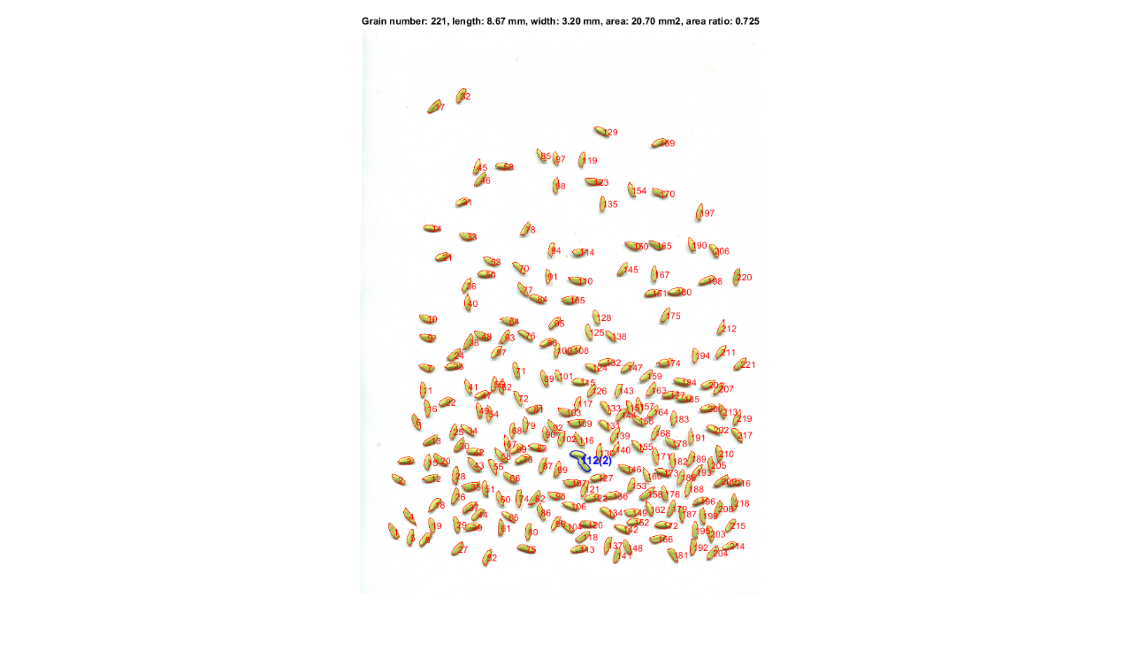

**Figure 7.4 An example of generated ‘check result’ image. T**he extracted parameter values of this image is presented in the title, and edge of the recognized grains are highlighted, with the grain order written at the center of each grain. Note that for grains in aggregation, they are highlighted in blue.

**Note:** The extracted parameters in each image are stored in fileDir/result_clean.txt, the raw data for all grains are stored in fileDir/result_raw.txt. In fileDir/result_clean.txt, the first column is name of images, the following columns are grain number, grain average length, grain average width, grain average area and grain area ratio (grain_area/[grain_len*grain_width]).

Welcome to use these tools. Any bug is welcomed to report to [1664059681@qq.com](mailto:1664059681@qq.com).

© 2014-2018 Tiangen Chang All Rights Reserved